Low cost Hydrophone amplifier with high input impedance. Type A1001

Small amplifier intended for building in together with a small battery like a 9Volt PP3 or a 12Volt accu. Powersupply cable is delivered with the unit.
Highpass filter and Gain settings are to be preset internally with a screwdriver.

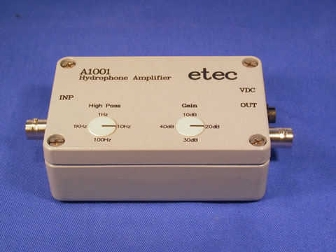
Description A1001
Hydrophone Voltage Amplifier
Very low noise. Extremely high input impedance.
Wide frequency bandwidth. Low current consumption.
Small and handy version.
Includes presets for High Pass filter and Gain controls.
BNC connectors In and Out.
Water splash proof.
Intended for use in the field or for building in together with a battery

Technical data. A1001  Gain Control :  Highpass Filters :  Filter Responses :  Frequency Range :  Relative Input Noise : | +10 +20 +30 +40dB  1 / 10 / 100 / 1kHz  1st.order Low Pass RC network.  1Hz to 1MHz  <1uVolt rms @ 1kHz (bw=500Hz...8kHz)

Input for Piezo ceramic transducer  with a capacitance of 100pF to 10nF  Recommended type : RESON / TC4033  Input impedance : 1Gohm // 5pF  Relative input noise :  < 2.0 microVolt at 10dB gain  < 1.5 microVolt at 20dB gain  < 1.2 microVolt at 30dB gain  < 1.0 microVolt at 40dB gain  Noise bandwidth : 500Hz to 8kHz  High Pass filter to filter off seawaves.  -6dB at 1Hz / 12dB pr.octave  -3dB at 10Hz, 100Hz and 1kHz  6dB pr.octave at 10Hz, 100Hz and 1kHz | GAIN control in 10dB steps  High frequency limit depends on gain setting :  1MHz at 10dB gain  800kHz at 20dB gain  600kHz at 30dB gain  300kHz at 40dB gain  Output level max.+10dBm at 12Vdc  Output level max.+20dBm at 24Vdc  Output imp.: 10R+100uF  Cable drive: 50meter max.

