Hydrophone amplifier with high input impedance, envelope detector and build in batteries. Type A1101

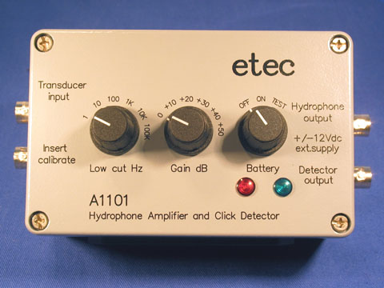
Hydrophone amplifier with batteries. Amplifier with build in 2 pcs. 9Volt PP3 batteris. This unit may also be powered by an external 12Volt battery or by a +/- 12Volt dual power supply.

Highpass filter and Gain settings may be operated on the frontpanel and the internal batteries can be tested for their charging condition.

The battery test lamps also function as a signal peak indicator for monitoring the signal level to prevent overloading of the following equipment.
The unit has a very low current consumption and the maximum operation time is appr. 24 hours on a set of full charged batteries.

The unit also contains an envelope or "click" detector which has a seperate output so the hydrophone signal and the envelope signal may be monitored simultaniously.

Description. A1101 :
Hydrophone Voltage Amplifier.
Very low noise. Extreme high input impedance.
Wide frequency bandwidth. Low current consumption.
Internal powered with 2 pcs.9volt PP3 batteries
Includes Highpass filter and Gain controls.BNC connectors In and Out.
Water splash proof. Intended for use in laboratory invironments and protected areas.
Technical data. A1101 :
Gain Control : | 0 +10 +20 +30 +40 +50dB
Highpass Filters : | 1Hz / 10 / 100 / 1k / 10k / 100kHz
Filter Responses : | 1st.order Low Pass
Frequency Range : | 1Hz to 1MHz
Relativ Input Noise : | <1uVolt rms @ 1kHz (bw=500Hz...8kHz)
Maximum input signal : | 3Vrms / 1Hz to 1MHz
Input impedance : | 1Gohm // 10pF
Input for Piezo ceramic transducer with a capacitance of 1 to 10 nF
like the RESON type TC4033
The relative input noise is less than 1.5 microVolt at 1KHz at Gain=20dB
Insert calibrate is for testing the the amplifier with the transducer connected to its input.
With a calibration signal of 1Vrms the signal on the hydrophone output must be -30dB plus the gain setting. Maximum calibration signal is 10Vrms
Low frequency filter to take off seawaves.
Frequencies noted are at -3dB.
Filterslopes are 6dB / octave
Gain control in 10dB steps
The high frequency response depends on gain setting.
At gain=0dB to +20dB > 1MHz
At gain=+30dB -> 600KHz
At gain=+40dB -> 200KHz
At gain=+50dB -> 50KHz
Power On/Off switch and Battery Test.
In position ON the amplifier is operating and will consume about 20mAmp from the batteries or from the external supply. In position TEST the current consumption is increased to 80mAmp in order to test the condition of the batteries.
The RED lamp indicates for the positive (left) battery.
The GREEN lamp indicates for the negative (right) battery.
If any of the lamp turns off during TEST the battery must be replaced or recharged.
Do NOT forget to switch back from TEST or it will drain your batteries quickly.
Battery test is not possible when the external power supply is connected.
The external supply does not recharge the batteries. Use an extern battery charger.

In the battery TEST condition the indicators are :
The RED lamp indicates for the positive (left) battery.
The GREEN lamp indicates for the negative (right) battery.
In normal operation both lamps will flash whenever the output signal hits 0dBm = 1.1Vpeak

NOTES on batteries in general :
Rechargeable batteries of type LR61 / 9Volt NiMh can be used.
They contain appr. 150mA-hours They will last appr. 8 hours with this amplifier.

Dry Cell batteries of type LR61 / 9Volt may be used if you want longer operation time.
They contain appr. 800mA-hours. They will last appr. 40 hours with this amplifier.
Dry Cell batteries cannot be recharged.
Batteries type LR61 are also called type PP3

Hydrophone output delivers the full frequency bandwith of the connected hydrophone.
Used for real time high speed recordings. Maximum output level is 5Vpeak.

External power supply is for long time service of this amplifier.
It will save the batteries as long as the supply voltage is higher than +/- 9Volt.
External supply cable is supplied with the unit.
Red banana plug is +12V, Black is 0V, Blue is -12V.

The "Click" detector output represents the amplitude modulated part of the hydrophone sonar signal in the frequency range from 20KHz up to 600KHz
The detected signal is known as the envelope information which is audible for the human ear.
The signal level is 6dB lower than the hydrophone output.

Outputs drive
Both outputs will be able to drive appr.50 meters of cable.

Do NOT forget to switch OFF the unit after use.
Store batteries in a cool place when not in use

