Multichannel Hydrophone Amplifier type B2204RC

Ultra compact unit with 4 individual high perfor-mance hydrophone amplifiers in a19inch rack with BNC connectors suitable for any type passive of hydrophones.

All amplifiers have individual on/off swithc and gain settings of 10dB to 60dB plus High pass and Low pass filters.

There are 6 steps each on both Hi- and Low pass filters and gain.
1Hz to 600kHz plus 10 to 60dB.

Price for 4 channels complete euro € 1.800,-
Campain sale ! less 20% in July only

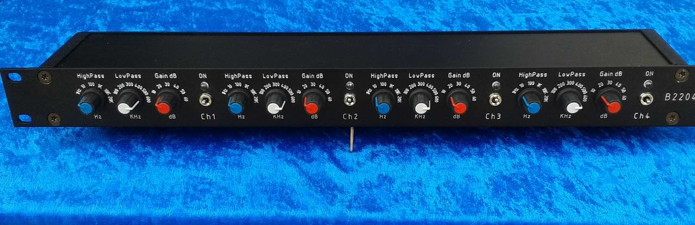

This 4 channel version was originally made for a customer who wanted a compact multichannel version of the Reson EC6081 / VP2000 amplfier.
It has been changed in some ways in order to make room for the 4 channels and
there is 6 now positions each available for the filter settings. The filters have also been changed to second order filters (the EC6081 filters are first order filters).

The filter and Gain settings are :
High pass : 1Hz - 10Hz - 100Hz - 1kHz - 10kHz - 20kHz
Low pass : 100kHz - 200kHz - 300kHz - 400kHz - 500kHz – 600kHz
Output Gain : 10dB - 20dB - 30dB - 40dB - 50dB - 60dB

Power supply : +/- 12volt DC – power supply mains adaptor is included.

